# Design Specification

Project design provide all detail of system development and key feature, structure, schedules, task are planned out. As well as components, models, interfaces and data. That information involved directly or indirectly in system development. In this project we create the blue print. Design project divided into three model these models are structural, Behavior and database model.

In Bus ticket booking system we use star UML tool to use create class diagram, DFD diagram, Activity diagram, sequence diagram. In this project I have use unified modelling language (UML).

# Structural design:

Structural model is the view of a system that emphasizes the structure of the objects, including their classifiers, relationships attributes and operations.

# Class diagram

Class diagram is a static model which is one of the most useful types of diagram in UML. in this diagram clarifies all classes in the system, classes, attributes, operation and relations between objects.

# DFD or flow chart

Data flow diagram is the graphical representation of flow of data from one component to another component in any information system.

Symbol in DFD are given below:

Process:

The activates carried out by the system which use and transform information.

Data flow:

The data flow is noted as names the arrow.

External Entities:

The source from which information flow in to the system and recipient of information leaving the system.

Data Store:

where information store in the system.

# Behavioral Design:

Behavioral is also knowing as Dynamic modelling in this design system which deals with every types of behavior in this system. In this model we have involved activity and Sequence diagram in this Bus Ticket booking system.

# Activity Diagram

It is a special kind of a state chart diagram that shows the flow from activity to activity within system. Activity diagram addresses the dynamic of system. They are especially important in modelling the function of system and emphasis the flow of control among objects. And activity diagram define different part of the system.

Symbol of Activity diagram are given below

Start point: This symbol is the beginning of the activity. The start points noted by black circle.



Activity: this symbol is the main block of activity

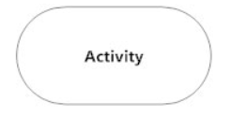

Action Flow:

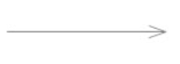

Decision symbol: Decision symbol represented by a diamond. In this symbol single input into two or more outputs.

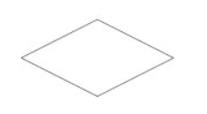

End point symbol: End point symbol is the last point of activity. This symbol represented by outlined black circle.

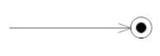

# Sequence Diagram

A Sequence diagram is an interaction diagram that emphasizes the time ordering the message.

Class Roles:

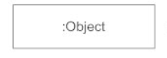

Activation:



# Database Model

Database model is the logical structure of database model and database model is the type of data model. It is the relational model and database model is the table-based format. In this model we can store the data for Bus ticket booking system.

# Data dictionary

Data dictionary is files or set of files. it records all the objects in the database. It is also dictionary of data and store all information in database.

# Entity Relation diagram

Entity Relation diagram is the logical structure and it shows relationship among entities sets. In this diagram the main component is entities set and relationship set.

Bus ticket booking system is given below:

# Architecture

# UI

# Prototyping

# 